

**Semester Two**

**Examination 2017**

**Question/Answer booklet**

**MATHEMATICS**

**SPECIALIST UNITS 3 & 4**

**Section One:**

**Calculator-free**

|  |
| --- |
| Student Name: _____________________________________ |
| Teacher’s Name: _____________________________________ |
|  |

**Time allowed for this section**

Reading time before commencing work: five minutes

Working time for paper: fifty minutes

**Material required/recommended for this section**

**To be provided by the supervisor**

This Question/Answer booklet

Formula Sheet

**To be provided by the candidate**

Standard items: pens (blue/black preferred), pencils (including coloured), sharpener, correction tape/fluid, erasers, ruler, highlighters

Special Items: nil

**Important note to candidates**

No other items may be taken into the examination room. It is **your** responsibility to ensure that you do not have any unauthorised notes or other items of a non-personal nature in the examination room. If you have any unauthorised material with you, hand it to the supervisor **before** reading any further.

**Structure of this paper**

|  |  |  |  |  |  |
| --- | --- | --- | --- | --- | --- |
|  | Number of questions available | Number of questions to be attempted | Working time (minutes) | Marks available | Percentage of exam |
| **Section One**  **Calculator—free** | **8** | **8** | **50** | **50** | **35** |
| Section Two  Calculator—assumed | 14 | 14 | 100 | 100 | 65 |
|  | | | |  | 100 |

**Instructions to candidates**

1. The rules for the conduct of Western Australian external examinations are detailed in the

*Year 12 Information Handbook 2017.* Sitting this examination implies that you agree to abide by these rules.

1. Answer the questions according to the following instructions.

**Show all your working clearly.** Your working should be in sufficient detail to allow your

answers to be checked readily and for marks to be awarded for reasoning. Incorrect answers given without supporting reasoning cannot be allocated any marks. For any question or part question worth more than two marks, valid working or justification is required to receive full marks. If you repeat an answer to any question, ensure that you cancel the answer you do not wish to have marked.

It is recommended that you **do not use pencil**, except in diagrams.

1. You must be careful to confine your responses to the specific questions asked and to follow any instructions that are specific to a particular question.
2. Spare pages are included at the end of this booklet. They can be used for planning your responses and/or as additional space if required to continue an answer.

* Planning: If you use the spare pages for planning, indicate this clearly at the top of the page.
* Continuing an answer: If you need to use the space to continue an answer, indicate in the original answer space where the answer is continued, i.e. give the page number. Fill in the number of the question that you are continuing to answer at the top of the page.

1. The Formula Sheet is **not** handed in with your Question/Answer Booklet.

# Section One: Calculator–free 35% (50 marks)

This section has **eight (8)** questions. Attempt **all** questions. Write your answers in the spaces provided.

Spare pages are included at the end of this booklet. They can be used for planning your responses and/or as additional space if required to continue an answer.

Working time: 50 minutes

**Question 1 (6 marks)**

Give exact expressions for each of the following in the form a + bi.

(a) 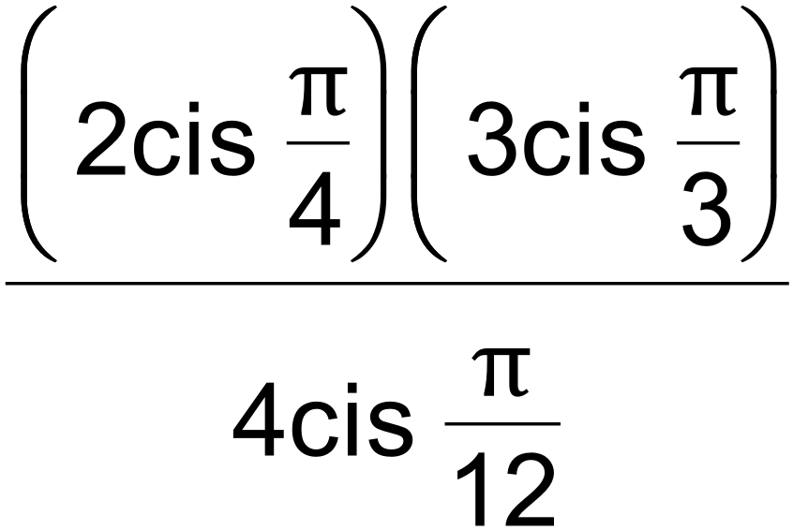 (1 mark)

(b) 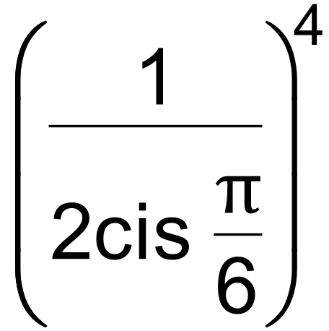 (2 marks)

(c) 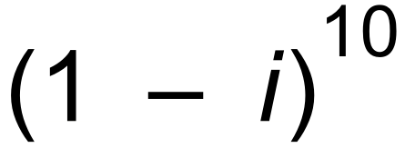 (3 marks)

**Question 2 (4 marks)**

Consider 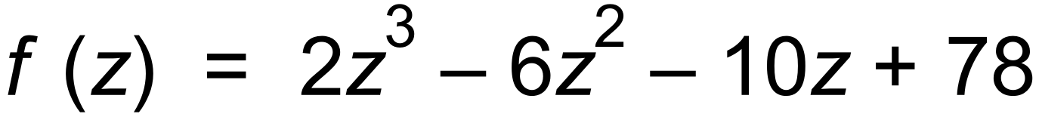.

Solve 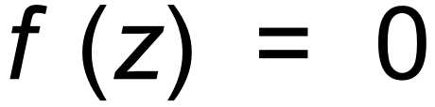, if we know that f (−3) = 0. (4 marks)

**Question 3 (4 marks)**

Consider the complex equation 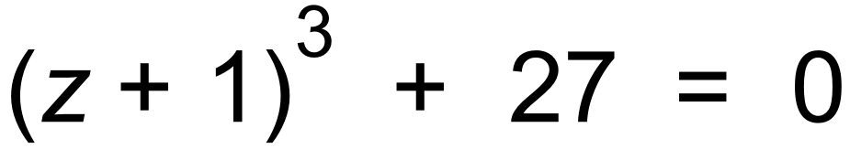.

Solve the equation, using De Moivre’s Theorem, leaving your answers in polar format. (4 marks)

**Question 4 (6 marks)**

(a) Express 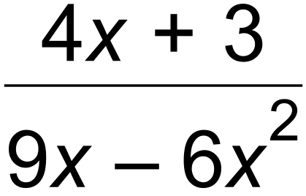 in the format 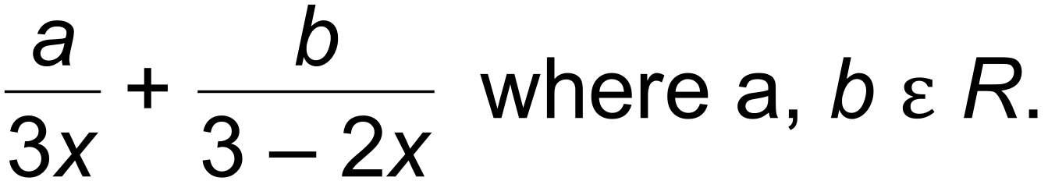 (3 marks)

(b) Hence, determine 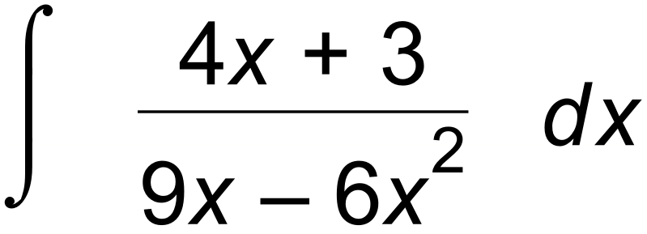. (3 marks)

**Question 5 (8 marks)**

Evaluate each of the following integrals.

(a) 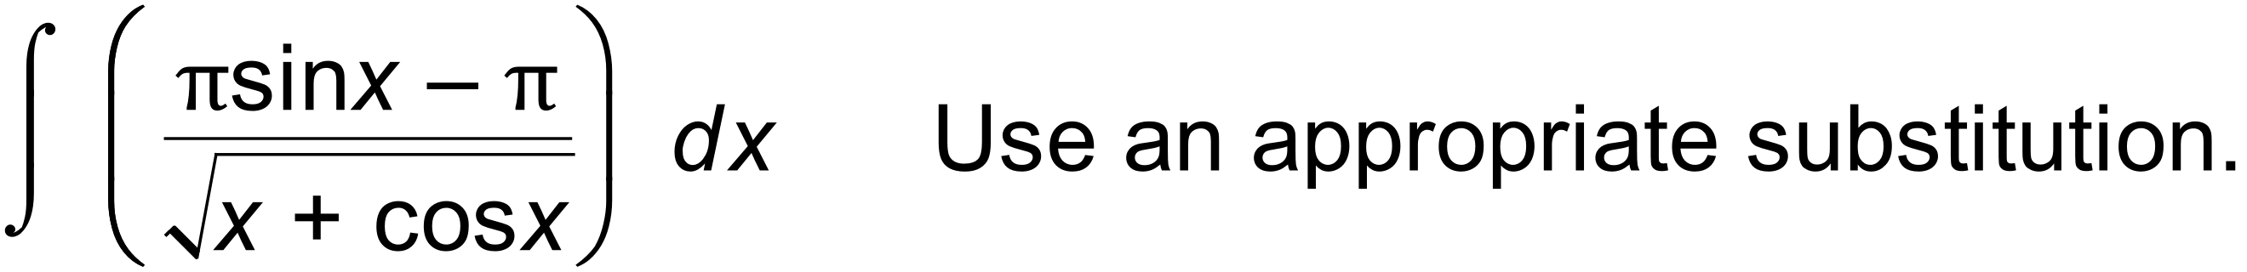 (4 marks)

(b) 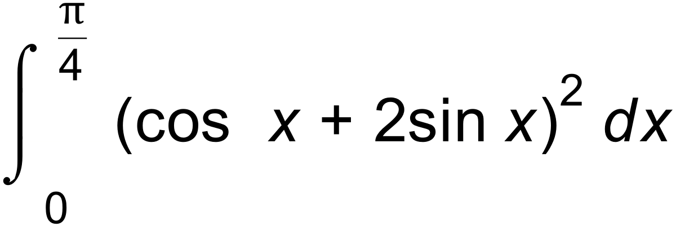 (4 marks)

**Question 6 (8 marks)**

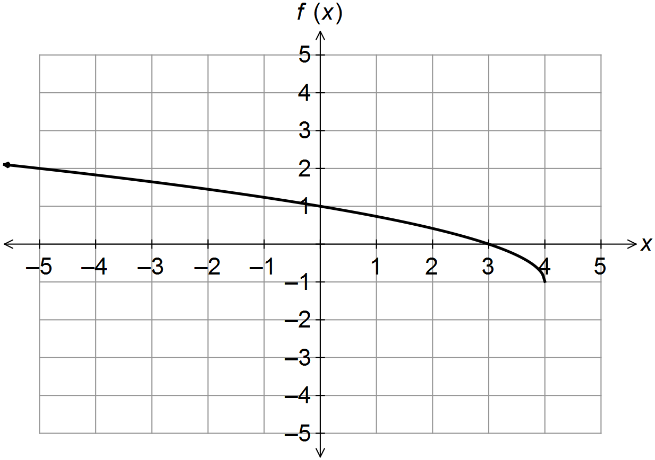(a) The graph of 

(i) Sketch the graph of 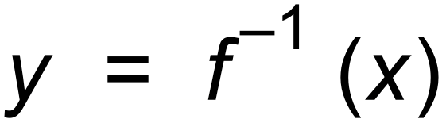 on the coordinate axes below. (1 mark)

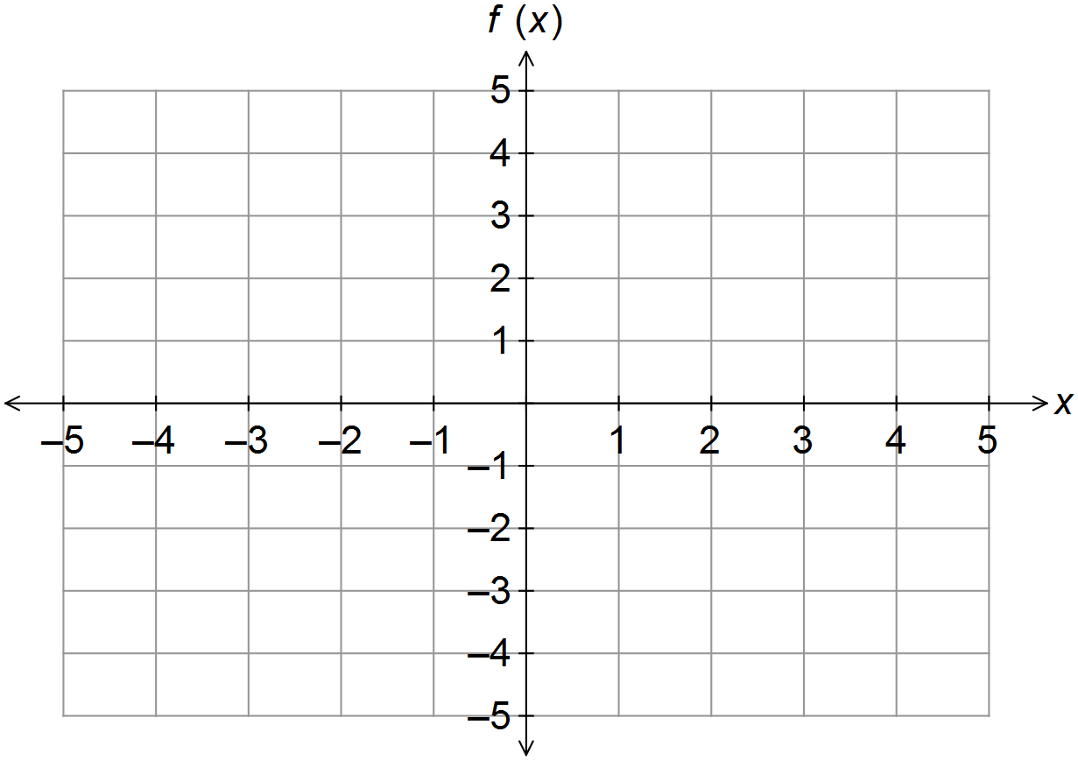

(ii) Sketch 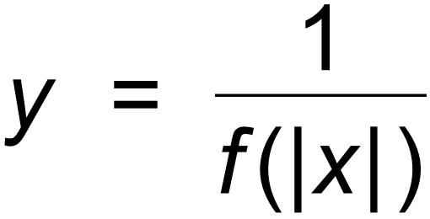 on the axes below. (4 marks)



(b) Given that g (x) = 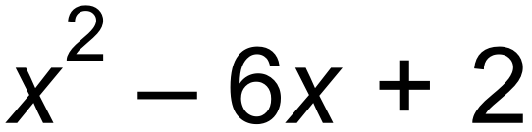, find 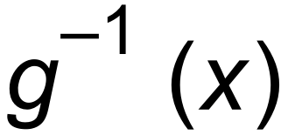, by restricting the domain of g (x) to its

largest allowable domain. (3 marks)

**Question 7 (6 marks)**

Points A, B and C have respective position vectors 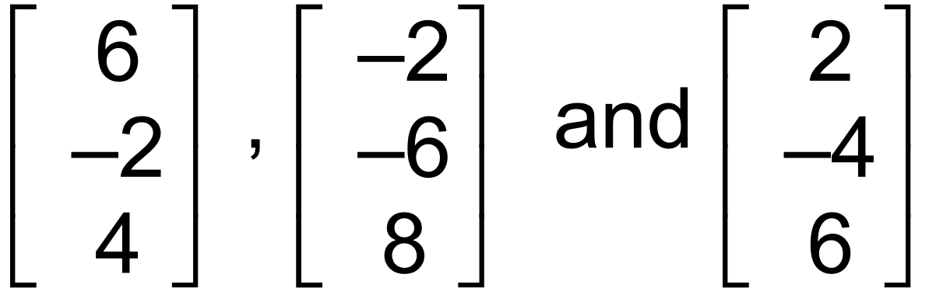.

(a) (i) State which point is the mid−point of the other two. (1 mark)

(ii) State which two points are equidistant from the origin. (1 mark)

(iii) Determine the Cartesian equation of the sphere with centre at the midpoint

found in (a) (i), and radius of 7. (1 mark)

(iv) Show why the point 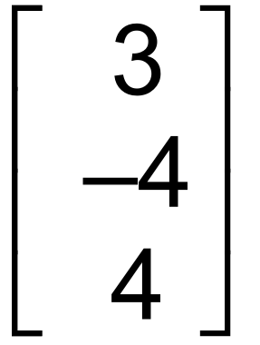 lies inside the sphere found in (a) (iii). (1 mark)

(b) Given O is the origin and 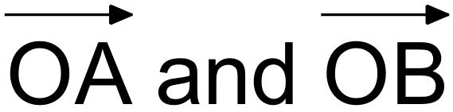 determine a plane, find two vectors that are normal

to this plane. (2 marks)

**Question 8 (8 marks)**

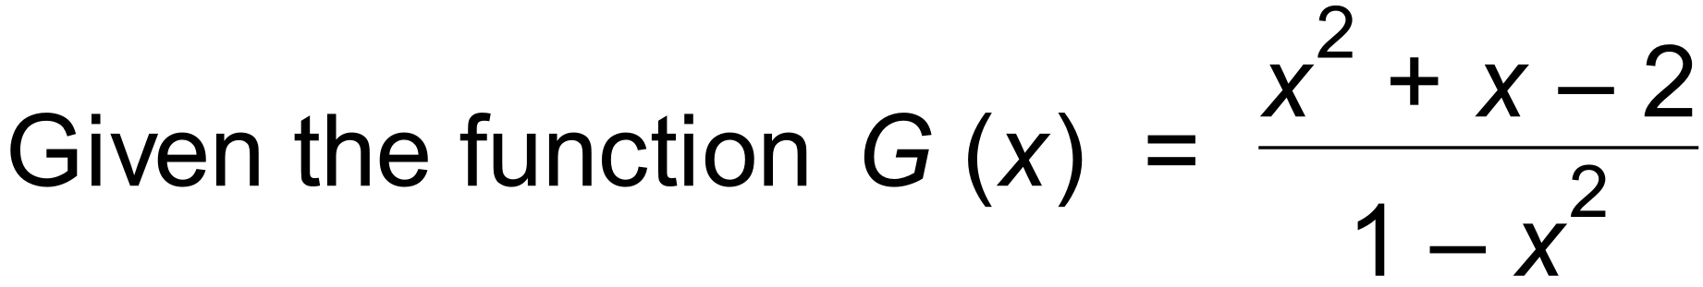 ,

(a) state all asymptotes, intercepts and any other important features of the graph of y = G (x).

(5 marks)

(b) sketch the graph of y = G (x) on the axes below. (3 marks)

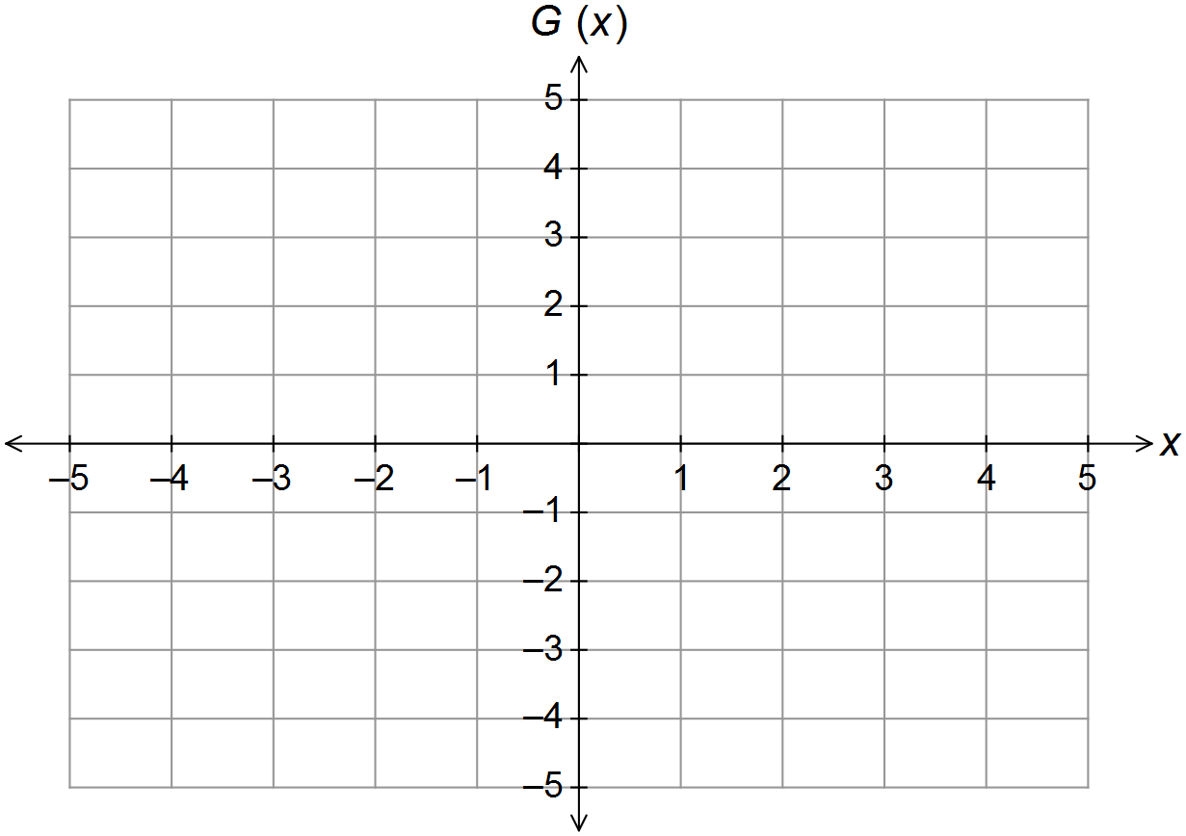

**End of Questions**

**Additional working space**

Question number(s): ……………………

**Additional working space**

Question number(s): ……………………